**A Study On Preprocessing A Mammogram**

**Image Using Adaptive Median Filter**

**Abstract**:

Digital mammogram becomes the most effective technique for early breast cancer detection modality and processing these images requires high computational capabilities. Computer image processing techniques will be applied to enhance images. This paper attempts to study about pre-processing is the most important step in the mammogram analysis due to **poor captured mammogram image quality.** Pre-processing is very important to correct and adjust the mammogram image for further study and processing. **Different types of filtering techniques are available for pre-processing. Filters are used to improve image quality**, The experimental results concludes that **the adaptive median filter is best for mammogram image noise removal and gives better performance by estimating the PSNR values**

A Mammogram is an x-ray of the breast that can reveal abnormalities like benign or malignant. Mammograms can be used for screening and for diagnosis.. Diagnostic Mammogram is performed to help detect breast cancer if a woman has symptoms, such as a lump that can be felt in her breast. Breast Cancer is one of the most common cancers, leading to cause of death among women, especially in developed countries. Mammography is currently the most effective imaging modality for breast cancer screening. Mammography is a radiographic imaging technique which is used to obtain breast images for diagnostic and screening purpose for early stage detection of cancer and the images are called mammograms which are obtained by using low dose radiation levels between specific intervals. Mammography plays an important role to detect abnormalities in the breast. It gives detailed information about anatomy, morphology and pathologies of breast for screening and diagnosis of breast cancer. **There is a difficulty to detect masses in mammograms because sometimes masses seemed to be similar to normal breast tissues on mammograms. It is difficult to distinguish between malignant and benign masses. Irregular shapes have a higher probability of being malignant and regular shapes have a probability of being benign. Difference in regions of the right and left breast is known as bilateral asymmetry of the breast.**

**RELATED WORKS**

. The related works are retrieved, analyzed are presented. Cervinka T [1] **the proposed method of the histogram of the intensity in CT images down sampled. Therefore, the low contrast and blurring regions in CT images enhanced.** A Markov Random Field model, which is consider the geometrical constraints of the processed image used to develop the accuracy resulting from the downsampling procedure. **Median filtering open morphological operation and contrast enhancement [2] used to reduce noise and also image enhancement.** Lai [3] used four selective averaging schemes and a modification of median filtering called selective median filtering. The Pre-processing technique used in medical images to remove special markings and unwanted noises.Morrow [4] the contrast of each region calculated with respect to its individual background. Background noise removing while preserving the edge information of suspicious areas can enhance a digital mammogram. Muller [5] the noise, poor image contrast, in homogeneity, weak boundaries and special mark existing in the medical image segmentation process extremely difficult to remove the noise and special markings that exist in medical images. The pre-processing method [6] including cutting out background area and normalization for CT brain images. In the proposed approach, an elliptical structure constructed based on skull contour and then the incline imaging angles corrected

**Median Filter**

A median filter is a nonlinear filter is efficient in removing salt and pepper noise median tends to keep the sharpness of image edges while removing noise. The several of median filter is Centre-weighted median filter Weighted median filter, Max-median filter, the effect of the size of the window increases in median filtering noise removed effectively.

**Mean Filter**

The mean filter replaces each pixel by the average value of the intensities in its neighbourhood. It can locally reduce the variance and is easy to implement. It has the effect of smoothing and blurring the image and is optimal for additive Gaussian noise in the sense of mean square error. Speckled image is a multiplicative model with non-Gaussian noise and therefore, the simple mean filter is not effective in this case.

**Adaptive Mean Filter**

In order to alleviate the blurring effect, the adaptive mean filters have been proposed to achieve a balance between straightforward averaging and all-pass filtering. They adapt to the properties of the image locally and selectively remove speckles from different parts of the image. The uses of local image statistics such as mean, variance and spatial correlation to effectively detect and preserve edges and features. The speckle noise is removed by replacing it with a local mean value. The adaptive mean filters outperform mean filters, and generally reduce speckles while preserving the edges.

**Histogram Equalization**

This technique corresponds to redistribution of gray levels in order to obtain uniform histogram. In this case every pixel

is replaced by integral of the histogram of the image in that pixel. Histogram equalization is a method in image processing of contrast adjustment using the image's histogram. Through this adjustment, the intensities can be better distributed on the histogram. This allows for areas of lower local contrast to get better contrast. Histogram equalization

accomplishes this by efficiently spreading out the most frequent intensity values. The method is useful in images with backgrounds and foregrounds that are both bright or both dark. In mammogram images, Histogram equalization is used to make contrast adjustment so that the image abnormalities will be better visible.

**PROPOSED METHODOLOGY**

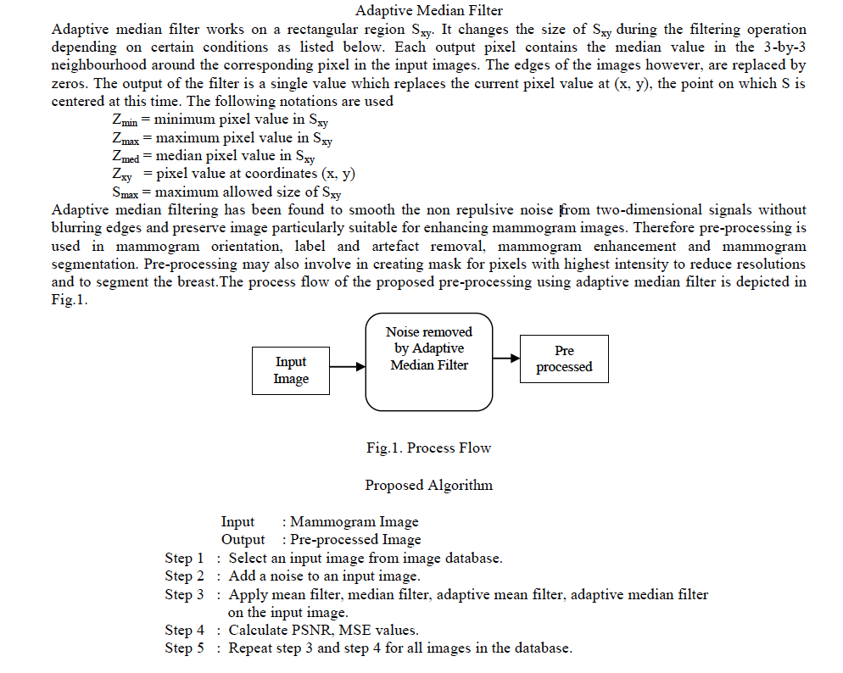

**From the experimental and results it is conclude that adaptive median filter is best for mammogram image noise removal gives better performance by estimating the PSNR values**

